

MESM GROUP PROJECT PROPOSAL 2023-2024

GLOBAL FOOD PRODUCTION & FOOD WASTAGE HOTSPOT ANALYSIS

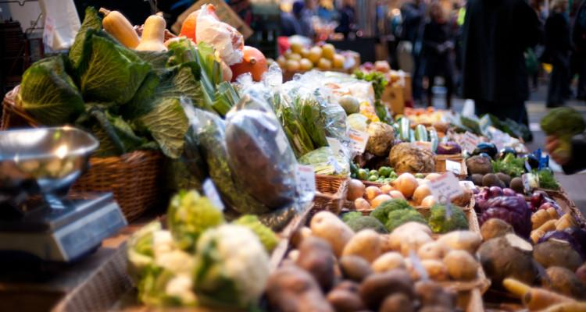

GROUP PROJECT MEMBERS Kathryn Tomasi | Masters Candidate, 2024 | kathryntomasi@bren.ucsb.edu | (917) 340-1729 Henry Bushell | Masters Candidate, 2024| hbushell@bren.ucsb.edu | (516) 477-7140
Isaiah Fowler | Masters Candidate, 2024 | isaiahfowler@bren.ucsb.edu | (702) 510-1454 Mika Munoz | Masters Candidate, 2024 | munoz927@bren.ucsb.edu | (773) 931-1127 Sridhar Iyengar | Masters Candidate, 2024 | sridharvasu@bren.ucsb.edu | (805) 259-0336

CLIENT – United Nations Environment Programme Llorenç Milà i Canals | Programme Officer | llorenc.milaicanals@un.org
Clementine O’Connor | Programme Management Officer | clementine.oconnor@un.org Helena Rey de Assis | Programme Officer, Consumption & Production Unit | helena.rey@un.org

FACULTY SUPPORT – Bren School of Environmental Science & Management Roland Geyer | Professor in Industrial Ecology | geyer@bren.ucsb.edu David Tilman | Distinguished Professor in Ecology, Biodiversity, Ecosystem Functioning | tilman@bren.ucsb.edu

OBJECTIVES

The primary goal of this project is to aid the United Nations Environment Programme (UNEP) in evaluating past, present, and future conditions of global food production and food wastage. UNEP has a program to reduce food waste by 2030, and by partnering with Bren, we will come up with a life cycle environmental hotspot and improvement analysis of global food production and food wastage.

While top-level global footprints exist, contribution/hotspot analyses of food types are of high interest, and much rarer. Data sets on global food production combined with environmental intensities and contribution analyses of certain food groups will allow us to zoom in on environmental hotspots within food types.

The FAO Food Wastage Footprint was developed in 2013, estimating the greenhouse gasses, water, land use, and biodiversity impacts of food loss and waste, but has not been updated at a global level in the last ten years. With FAO, we are keen to update these estimates using new food loss and waste data and come up with a methodology that becomes a lot more granular about food waste modeling and the fate of food wastage.

A tentative scope of work (SOW) is as follows:

Based on data available, e.g., from the Food and Agricultural Organization (FAO), the Bren students will develop an inventory of global food production during a recent year.

Next, the Bren students will collect available life cycle assessment (LCA) and environmental footprint data for each food category and rank the data by total impact from the number derived from the annual production totals x environmental intensity. Based on the LCA data available, the number of food categories may be increased or decreased. Another task in this third step is to determine the type and quantity of environmental impact indicators used in this project.

Third, contribution analyses and other details available in the LCA and environmental footprint data will be used to identify environmental hotspots in global food production. A potential fifth task and stretch goal is to look for ways to address the identified environmental hotspots.

Fourth, after generating the environmental footprint of global food production, use that information to generate an environmental footprint of food wastage.

Specific objectives include:

- Based on existing top-level footprints, create a rank-ordered list of food items with the largest global footprints (probably based on greenhouse gasses)
- Pick the top ten or so and collect contribution analyses of them. For each food type find the hotspots and their drivers, while also considering variability due to location and production method
- For each food type, identify impact mitigation strategies and make recommendations based on them
- Pivot towards the food waste question in a way that becomes a lot more granular about food waste modeling
  - Get food production footprints and multiplying this wastage percentage to food production
  - Look into where this happens and research and aim to build a better and more updated model of food wastage

